FOR 3456 / 3457 – Forest Watershed & Forest Fire Management

Lab Session 1 (January 10th & 12th, 2018) - Soil Water Retention, Infiltration & Movement

Information & Definitions:
Saturation Point (SP) – The percentage of water required to fill all the voids between soil particles with a liquid, or form the most concentrated solution possible under a given set of physical conditions in the presence of an excess of the solute.
Field Capacity (FC) – The percentage of water remaining in the soil 2 or 3 days after the soil has been saturated and free drainage has practically ceased. The percentage may be expressed in terms of mass or volume.

Permanent Wilting Point (PWP) – The moisture content of a soil at which plants (specifically sunflower plants) wilt and fail to recover their turgidity when placed in a dark, humid atmosphere. The wilting point is commonly estimated by measuring the 15-bar percentage of a soil.

Hygroscopic Point (HP) – Water adsorbed by a dry soil from an atmosphere of high relative humidity; water lost from an air-dry soil when it is heated to 105°C; water held by the soil when it is at equilibrium with an atmosphere of a specified relative humidity at a specified temperature, usually 98% relative humidity at 25°C.

Soil water is classified into three categories: (1) excess soil water or gravitational water, (2) available soil water, and (3) unavailable soil water.

Excess soil water or gravitational water drains or percolates readily by gravitational force. Since drainage takes time, part of the excess water may be used by plants before it moves out of the root zone.
Available soil water is retained in the soil by capillary forces and can be extracted by the plant. This soil water is most important for crop production. It is the water held by the soil between field capacity and wilting point. Plants can use approximately 50 percent of the available water without stress. When less than 50 percent of available water remains, stress can occur.
Unavailable water is soil water held so firmly to soil particles by adsorptive soil forces that it cannot be extracted by plants. Unavailable water remains when soil is direr than wilting point.

Other Definitions…
Field capacity is the water content of a soil at the upper limit of the available water range. It is the amount of water remaining in a soil after it has been saturated and allowed to drain for 24 hours.
Permanent wilting point is the lower limit of the available water range. When plants have removed all of the available water from a given soil, they wilt and do not recover. Thus, the water available for plant growth exists between the range of field capacity and wilting point.
Available water capacity is all the water that a soil can possibly hold between field capacity and wilting point. The capacity varies with soil texture.
Volumetric water content is the total amount of water that a soil holds at a particular time. It includes the available, unavailable, and gravitational water, if present. Volumetric water content is the fraction or percent of water in the total soil volume. Sands, loams, and clay loams reach saturation when volumetric water content is 45 percent, 48 percent, and 52 percent, respectively.
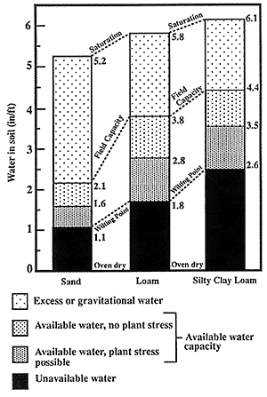

Student Name(s): ______________________________________________________

Soil Information - Site: ________________________ Horizon: ____________

PART A – Plastic & Liquid Limit Determinations

Procedure Steps:

- You are provided with the following materials:

  - One soil sample
  - Stir-rod
  - Distilled water
  - Plastic Cup

- Weigh and record each item separately below:

A - Mass of plastic cup + stir-rod __________g

B - Mass of cup + ½ dry soil + stir-rod __________g

C - Mass of dry soil (= B – A) __________g

- Add enough water to your sample (while stirring), so that it forms a thick, clumpy paste. This means that the soil will tend to clump together, sticking to the stir-rod. Once you have reached this point, your soil sample is considered to have reached its “plastic limit” (in terms of moisture content).

D - Mass of cup + wet soil + stir-rod __________g

E - Mass of water added to soil ( = D – B) __________g

F - % moisture content @ plastic limit (PL) __________%
%PL MC
=
Mass of water (g)
Mass of dry soil (g)
(
)
X 100
E
C

- Now add very small amounts of water (drops at a time) to your wet soil, and continue to stir until the soil attains the consistency similar to a “thick soup”…where if you take out the stir-rod, the slurry will form a peak and then fall back in on itself.

*Check with instructors if unsure about proper consistency!
*Note: Sandy soils will be more difficult to reach this consistency.

G - Mass of cup + saturated soil + stir-rod __________g

H - Total mass of water added to soil (= G – B) __________g

I - % moisture content @ liquid limit (LL) __________%

%LL MC
=
Mass of water (g)
Mass of dry soil (g)
(
)
X 100
H
C

PART B – Soil Moisture Retention Determinations

Procedure Steps:

- You are provided with the following materials:

  - One soil sample per student
  - Plastic spoon
  - Distilled water
  - Plastic cup
  - One ceramic filter crucible
  - Filter paper (1 piece)

- Weigh and record each item separately below:

J - Ceramic crucible with filter paper __________g

K - Ceramic crucible +filter paper + dry soil __________g

L - Mass of dry soil (= K – J) __________g

Soil Saturation – SAT MC %

Fill ceramic crucible (filter paper in bottom) with soil, and fill one large plastic cup ½ with water. Gently place ceramic crucible with dry soil into the water, and allow for the water to be absorbed by the dry soil through capillary action. Once the surface of the soil becomes noticeably moist / wet, remove the ceramic crucible and saturated soil from the water, and gently remove any excess water from the bottom. Place the ceramic crucible on the weigh scale and record mass.

*Saturated soil

M - Ceramic crucible +filter paper + wet soil __________g

N - Mass of water (= M – K) __________g

O - Moisture content @ saturation __________% (SAT)
%SAT MC
=
Mass of water (g)
Mass of dry soil (g)
(
)
X 100
N
L

Soil Field Capacity – FC MC %

Proceed to the suction device. Give your saturated sample to the lab assistant.

Following suction, weigh the sample again and record the mass on your lab sheet. Finish all necessary calculations and post results. DO NOT DISPOSE OF THE CRUCIBLE & MOIST SOIL!

Subject soil to 0.1atm negative pressure

P - Ceramic crucible +filter paper + moist soil __________g

Q - Mass of water (= P – K) __________g

R - Moisture content @ field capacity __________% (FC)

%FC MC
=
Mass of water (g)
Mass of dry soil (g)
(
)
X 100
Q
L

Soil Permanent Wilting Point – PWP MC %

Determination of PWP for selected soil samples will be carried out by the lab instructor, and all results will be included in the combined class dataset. This file will be updated with results from the Friday lab section the following week.

Soil Hygroscopic Point – HP MC % (sample preparation only)

Take the small (1/2 oz.) plastic cup, weigh it…then fill it with dry soil, then weigh it again. Record your results below.

Label your soil cup with the site and horizon, and then place it into the humidifying apparatus (at the front). It will take 2 – 3 days for the sample to properly attain the moisture content to be at its hygroscopic point.

S - Plastic cup mass __________g

T - Mass of plastic cup + dry soil __________g

U - Mass of dry soil (= T – S) __________g

V - Mass of plastic cup + moist soil (after 2 days) __________g

W - Mass of water (= V – T) __________g

X - Moisture content @ hygroscopic point __________% (HP)

%HP MC
=
Mass of water (g)
Mass of dry soil (g)
(
)
X 100
W
U

Combined class dataset and lab results will be posted on the Forest Watershed Research Center website (http://watershed.for.unb.ca/education/undergraduate-studies/for-3456/).

PART C – Soil Permeability Determination

Estimating Soil Permeability (K)

Procedure Steps:

- You are provided with the following materials:

  - Two (2) soil permeability apparatuses (tube and beaker)
  - One soil sample
  - Plastic spoon
  - Beaker with distilled water
  - Weigh-scale

- Weigh and record each item separately for both permeability apparatuses:

“Loose” Tube Apparatus:

1 - Mass of loose perm tube setup ____________ g

2 - Mass of glass beaker ____________ g

3 - Total mass of apparatus (= 1 + 2) ____________ g

“Compact” Tube Apparatus:

4 - Mass of compact perm tube setup ____________ g

5 - Mass of glass beaker ____________ g

6 - Total mass of apparatus (= 4 + 5) ____________ g

- Loose Soil -

*Fill tube approx. ⅓ full (3 – 3.5cm) with soil and DO NOT COMPACT, fill in the following:

A - Mass of dry soil in tube __________ g
(Refer to Procedure Step # 3)
B - Mass of moist soil in tube __________ g

C - Height of soil __________cm

D - Water head __________cm
DRY
E - Bulk density (Db loose) __________ g/cm³
MOIST
F - Bulk density (Db loose) __________ g/cm³

Equations for Soil Bulk Density (Db):
(C)
(A)
DRY
(E)
Db (loose) = Mass of Soil / (6.158 cm² x Height of Soil)

(C)
(B)
MOIST
(F)
Db (loose) = Mass of Soil / (6.158 cm² x Height of Soil)

- Compact Soil -

*Fill tube approx. ⅓ full (3 – 3.5cm) with soil and COMPACT by tapping the tube gently against the desk until there is a noticeable reduction in soil height, fill in the following:

G - Mass of dry soil in tube __________ g
(Refer to Procedure Step # 3)
H - Mass of moist soil in tube __________ g

I - Height of soil __________cm

J - Water head __________cm
DRY
K - Bulk density (Db compact) __________ g/cm³
MOIST
L - Bulk density (Db compact) __________ g/cm³

Equations for Soil Bulk Density (Db):
( I )
(G)
DRY
(K)
Db (Compact) = Mass of Soil / (6.158 cm² x Height of Soil)

( I )
(H)
MOIST
(L)
Db (Compact) = Mass of Soil / (6.158 cm² x Height of Soil)

- Once you have setup your soil permeability apparatuses, the next step is to slowly saturate the soil with water, this is done by…

  - Fill a beaker ½ full with water and insert tube with soil, allowing the end of each tube to be submerged in the water. Wait for saturation until the top of the soil in the tube is noticeably moist / wet.

  - Once soil saturation is achieved, remove tubes from beaker, empty and dry, replace tubes onto stand.

- Fill each tube to the top with water and begin timing (at the same time).

- Continue to top-up each tube with water while timing in order to maintain constant water head pressure.

- Once each beaker has filled approx. ¼ with water, stop timing, and record both the time and mass of water in beaker (subtract the empty beaker mass from the mass of the beaker + water) – below:

“Loose” Drain Time: __________ mins.

Water mass (loose): __________ g or cm³ = Q (loose soil)

“Compact” Drain Time: __________ mins.

Water mass (compact): _________ g or cm³ = Q (compact soil)

APPARATUS DIAGRAM
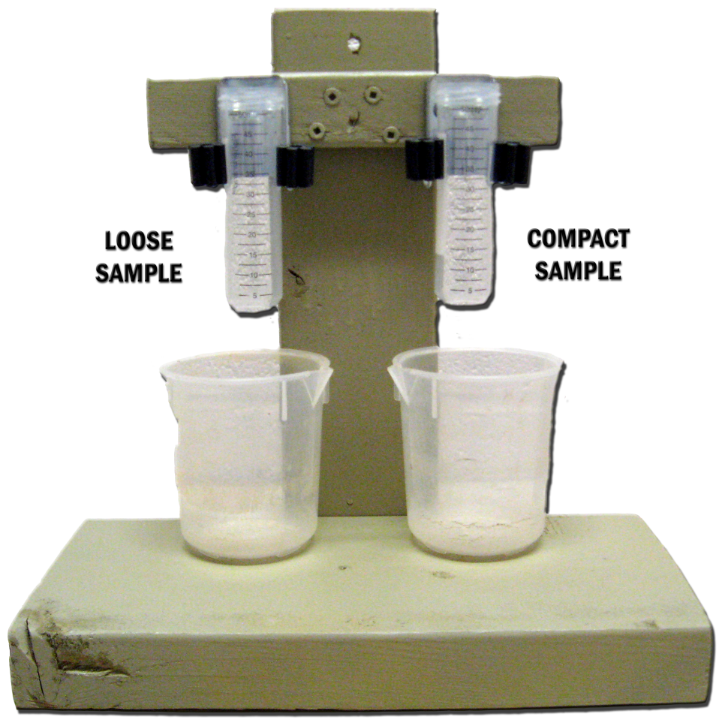

A = Surface area of tube in cm² (= approx. 6.158 cm²)
Q = Amount of water after time (t) in cm³
t = Time taken for Q to flow through soil in minutes (mins)
K = Substrate permeability in terms of water flow rate in cm/min
Equation for permeability:

K = [Q / (A*t)] / [(Soil Ht. + Water Ht.) / Soil Ht]

Therefore,

K Loose = ______________________ cm / min

K Compact = ______________________ cm / min

Percolation with Decreasing Water Head Pressure

- Using the same infiltration tube apparatus (as required previously for permeability estimation), empty and dry the beaker.

- Place tubes back on stand, fill tubes with water, and begin timing.

- Record water height measurements over time for both the “loose” and “compact” samples.

*NOTE – Measure the actual water height (in mm) only as it decresases!

*NOTE – Use the same time interval for measuring both samples.

- Continue to measure the water head over time (distance above soil surface)…taking a minimum of 25 measurements at regular time intervals (ex. 5, 10, 15, 20, 25, 30 secs., 1 min.,…etc.) until the water has completely drained from the tube (may not be necessary for the compact samples).

- Make duplicate copies of all information collected today, and don’t lose it! This information will be used next week for statistical prediction of the actual data collected.

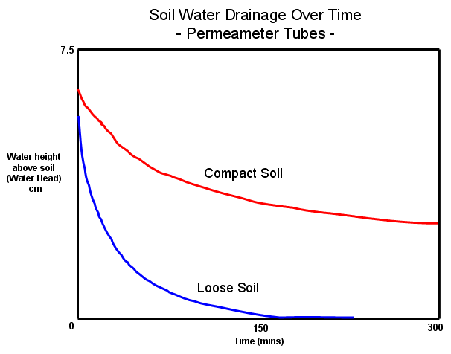

Plotted drainage curves should be similar to the example, as shown above. Shape and duration of the drainage curves will be entirely dependent upon soil sample characteristics, and the degree of compaction associated with each, within the tubes.

PLEASE SUBMIT A COPY OF YOUR RESULTS TO THE LAB ASSISTANT

